**VISVESVARAYA TECHNOLOGICAL UNIVERSITY**

**“JnanaSangama”, Belgaum -590014, Karnataka.**



**PROJECT WORK-3 REPORT**

**on**

**City Guide**

***Submitted by***

**P Sai Deekshith (1BM18CS148)**

**Ankit Kesar(1BM18CS150)**

**Pramod D Y (1BM19CS405)**

***Under the Guidance of***

|  |  |
| --- | --- |
| **Prof. Pooja S**  **Assistant Professor, BMSCE** |  |

***in partial fulfillment for the award of the degree of***

**BACHELOR OF ENGINEERING**

***in***

**COMPUTER SCIENCE AND ENGINEERING**



**B.M.S. COLLEGE OF ENGINEERING**

**(Autonomous Institution under VTU)**

**BENGALURU-560019**

**Sep-2020 to Jan-2021**

**B. M. S. College of Engineering,**

**Bull Temple Road, Bengaluru 560019**

(Affiliated To Visvesvaraya Technological University, Belgaum)

**Department of Computer Science and Engineering**



**CERTIFICATE**

This is to certify that the project work entitled “**City Guide**” carried out by **P Sai Deekshith (1BM18CS148), Ankit Kesar (1BM18CS150), Pramod D Y (1BM19CS405)** arebonafide students of **B. M. S. College of Engineering.** It is in partial fulfillment for the award of **Bachelor of Engineering in Computer Science and Engineering** of the Visveswaraiah Technological University, Belgaum during the year 2020-2021. The project report has been approved as it satisfies the academic requirements in respect of **Project Work-3 (20CS5PWPW3)**work prescribed for the said degree.

Signature of the Guide                 Signature of the HOD

Prof. Pooja S Dr. Umadevi V

Assistant Professor, Dept. of CSE Associate Prof.& Head, Dept. of CSE

BMSCE, Bengaluru BMSCE, Bengaluru

External Viva

Name of the Examiner                                                                                       Signature with date

1._____________________________ ________________________

2. _____________________________ _________________________

**B.M.S. College of EngineerinG**

**DEPARTMENT OF COMPUTER SCIENCE AND ENGINEERING**



***DECALARATION***

We,P Sai Deekshith (1BM18CS148), Ankit Kesar (1BM18CS150), Pramod D Y (1BM19CS405) students of 5th Semester, B.E, Department of Computer Science and Engineering,B. M. S. College of Engineering, Bangalore, hereby declare that, this Project Work-3 entitled "City Guide" has been carried out by us under the guidance of Dr.Umadevi V,Associate Professor, Department of CSE, B. M. S. College of Engineering,Bangalore during the academic semester Sep-2020-Jan-2021

We also declare that to the best of ourknowledge and belief, the development reported here is not from part of any other report by any other students.

Signature

P Sai Deekshith (1BM18CS148)

Ankit Kesar (1BM18CS150)

Pramod D Y (1BM19CS405)

2. **INTRODUCTION**

### **Overview**

### City Guide is a mobile application under android platform that is developed for local and new residents of the city which helps the user to view different places within the city and assists in searching for hotels, restaurants, movie halls and other categories. The application comforts a people in a city by showing information of all the nearby sites that can be used for public access. This application also gives the privelage to the people or owners to add their business locations such as restaurants, shops etc inorder to promote their business. The ratings given by the people helps in deciding the best place of their choice.

This application basically includes two main modules:

* First module is the user module where the user can be a local or new resident of the city and he can view the places within the city such as shops, hotels etc.
* Second module is the owner module where the owner can add his business locations so that it can be viewed by other people inorder which in turn helps him to grow his business.

### **Motivation**

The main motivation for developing this mobile application is to help local and non local residents of the city to view different categories of places in the city such as hotels, restaurants, shop, movie halls etc and can also view the featured locations of the city.

One of the other motivation is to help the owners to add their business locations which can be viewed by the users of the application and this in turn promotes their business.The ratings of the places can help the people mainly the new residents of the city to select the best place under a category of his choice.

1. **OBJECTIVES**

* Enable users to navigate places within the city easily, for example to hotels, tourist sites, banks and shopping places
* Provide list of service providers with their service .In case of hotels, with a short description and the address.
* Enable owners to add their places inorder to promote their business.

1. DATABASE

We are using the firebase Real Time database for our application, it has following tables

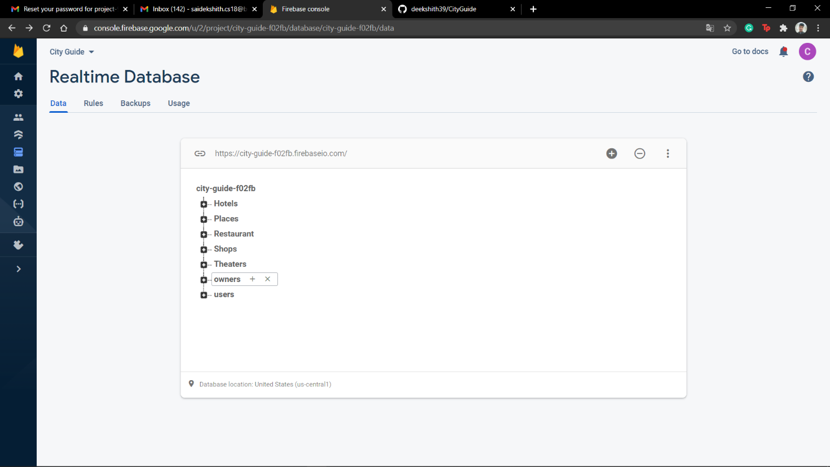

Restaurant Entries

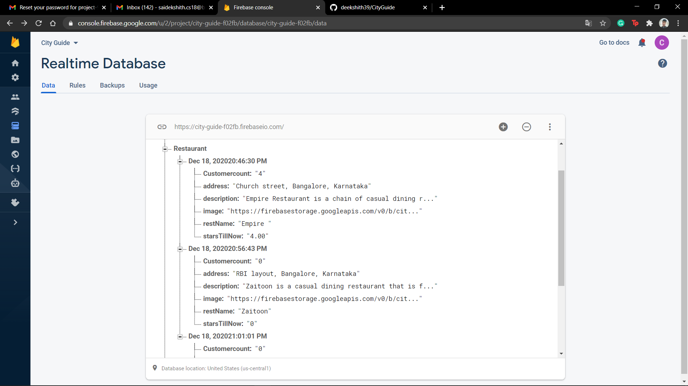

Users table:

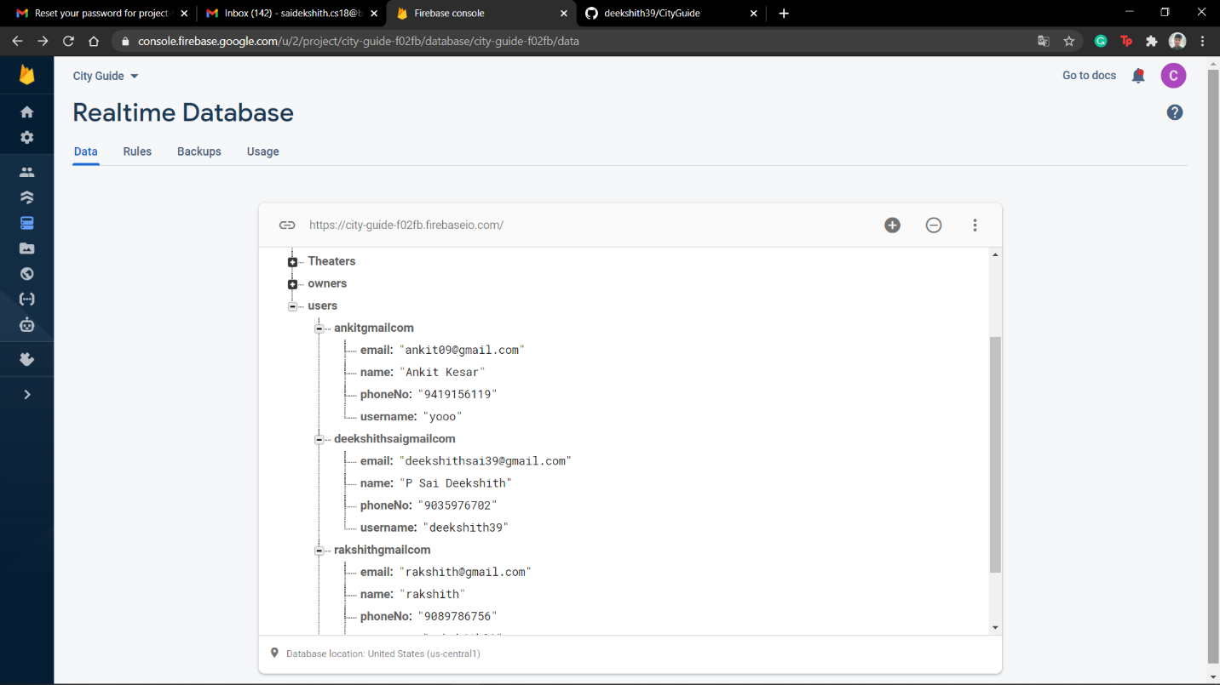

Owners table:

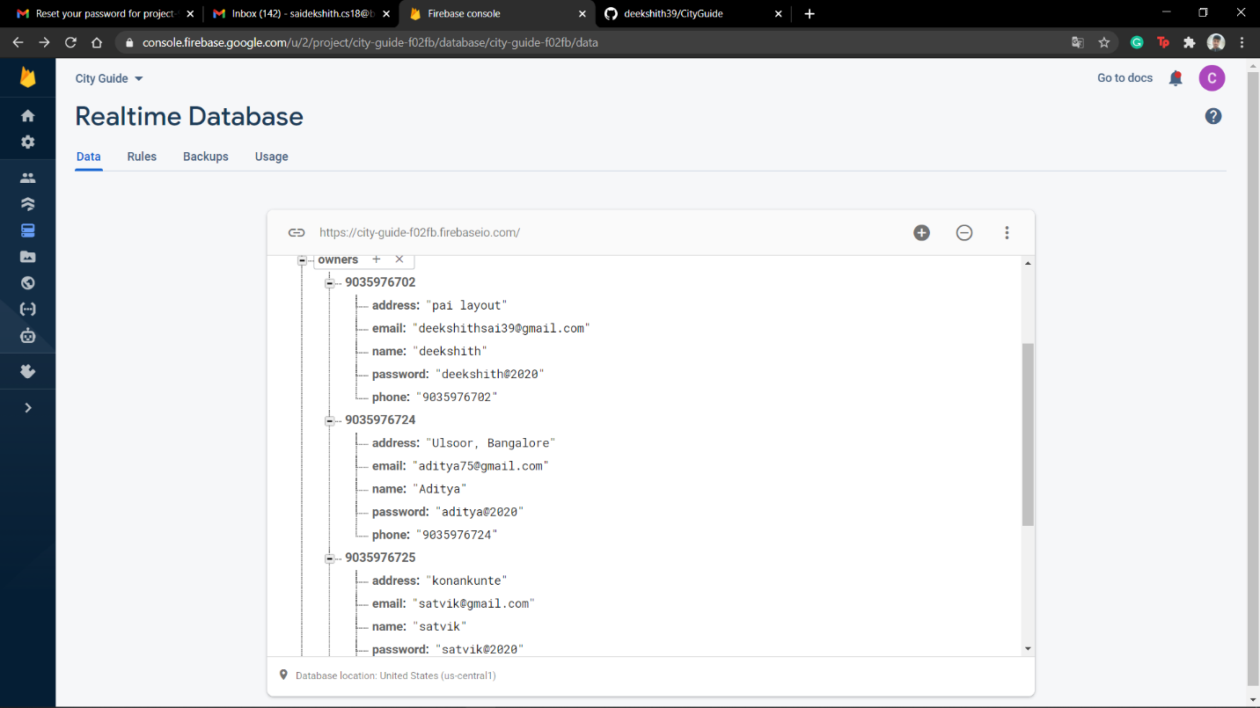

4. Design Layouts: Screen Shots of Mobile App

The Splash is opening page of our application.

Splash Screen:



User Login page:

The first page of our application provides the user to either login as an customer, or as a owner

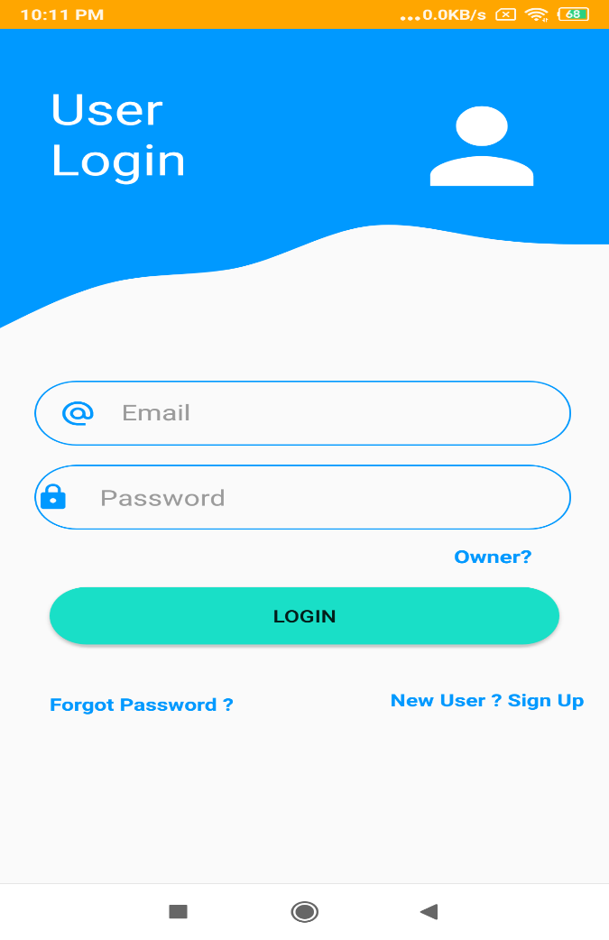

He/she can use Forgot Password Feature incase he don’t remember his/ her login info

User SignUp Page:

If anyone is new in our application he can sign up from this page

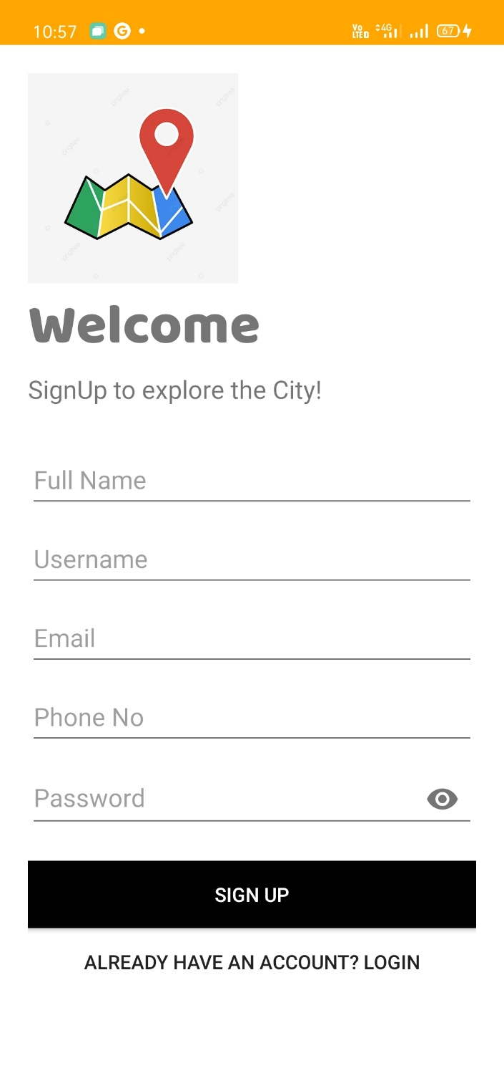

User Dash Board Page:

This is main Page of our application it connects whole application

From here user can navigate the hotels, restaurants , Theater or shops

registered on our application.

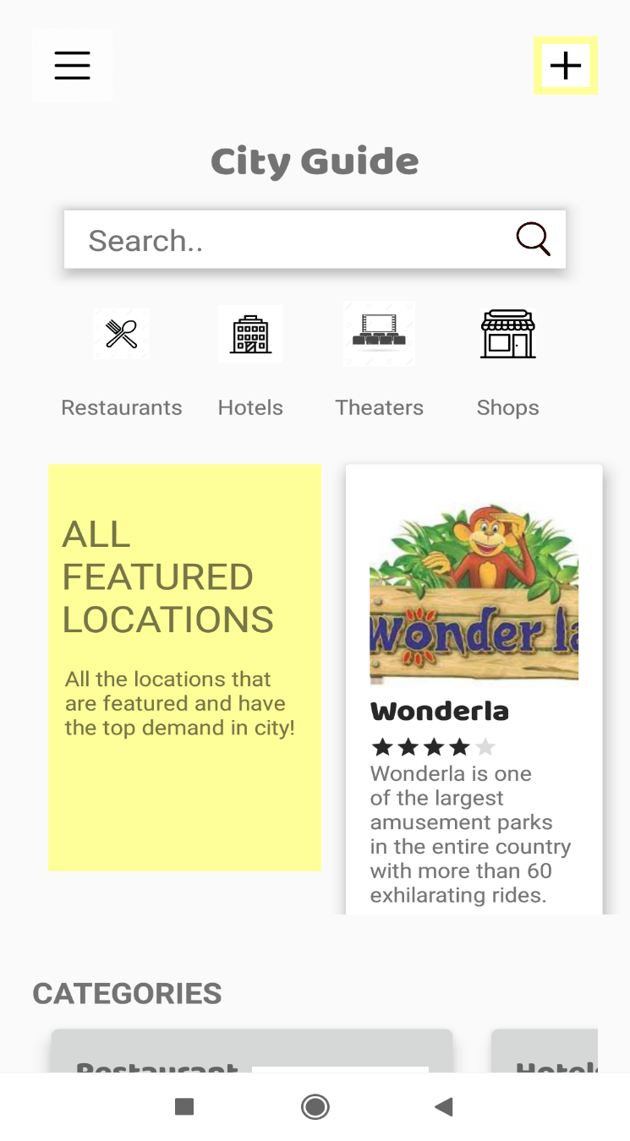

Navigation bar:

This our navigation bar from here he/she can go to desired feature

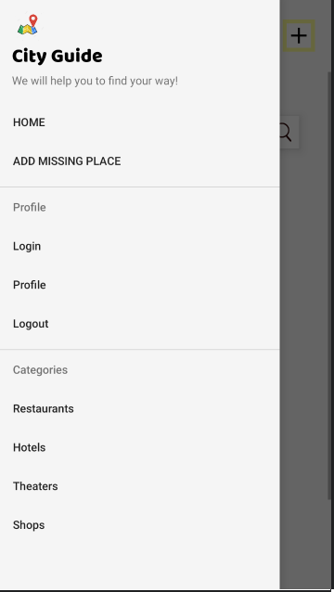

Category List View:

This is the List view of Restaurants available in the city . User can get to know about their services and reviews of other customer

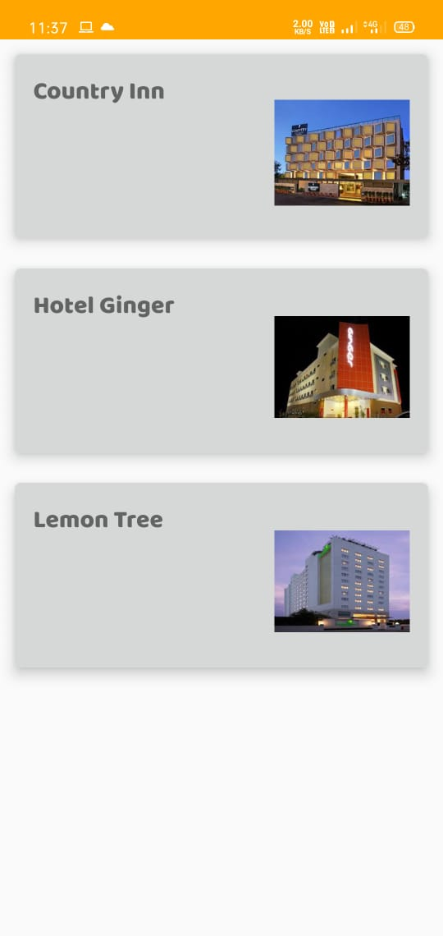

Category Details Page:

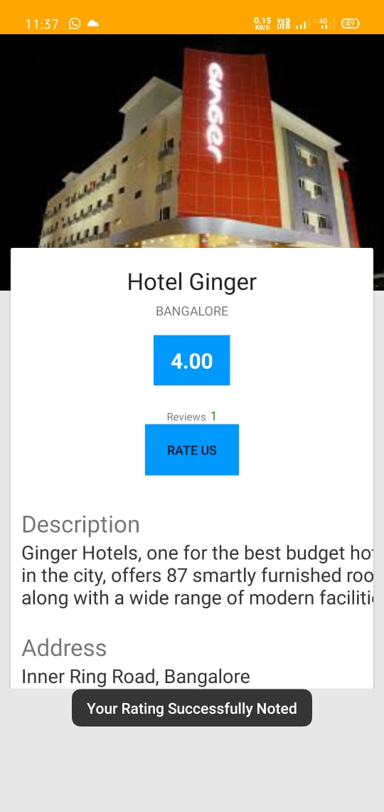

Here user can see the reviews of the Hotels, restaurant or shops and select the desired place to spend time. Also after using the services user can give the reviews on this place

Category Review Page:

This is our rating bar system here customer after using there services can give the rating so it would be helpful for other customer to select the place accordingly

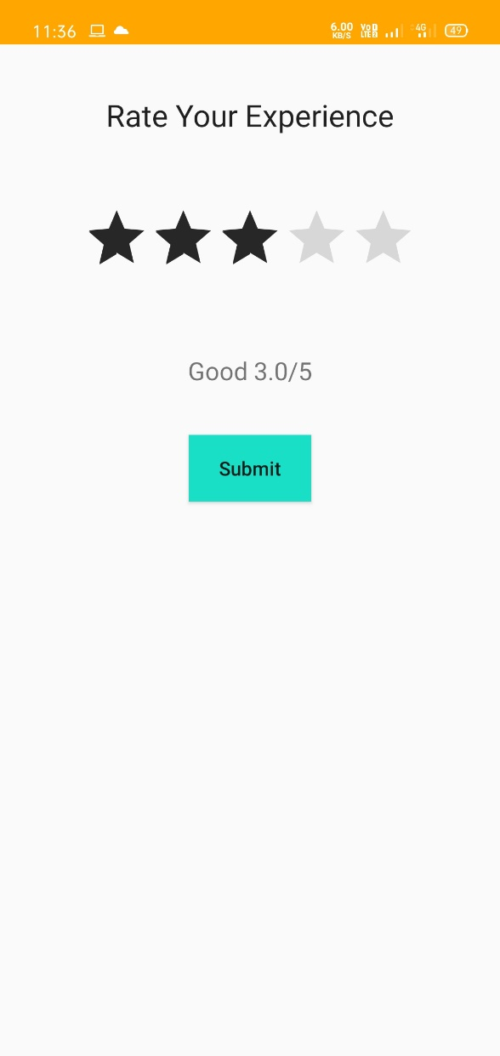

All other categories(Shops, theaters, hotels) will have the same view similar to this.

Owner Startup Page:

Also there is one more feature of our app. Here owner can register there place in our applications. For now only Hotels, restaurants ,shops and theater are available



Owner Login Page:

This is owner login page

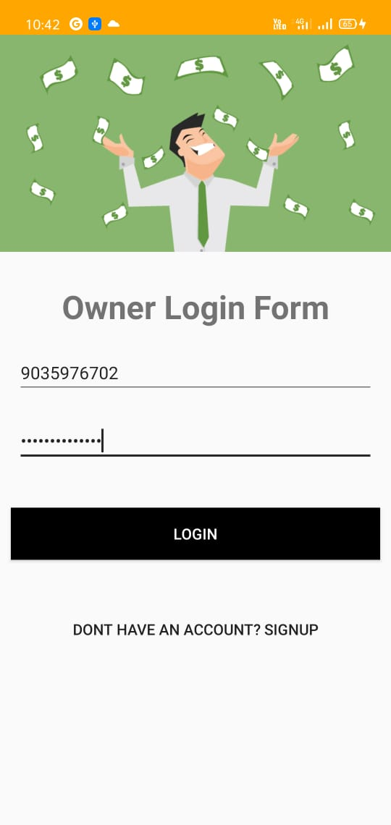

Owner Signup Page:

If someone is new to our application he can use this page to register.

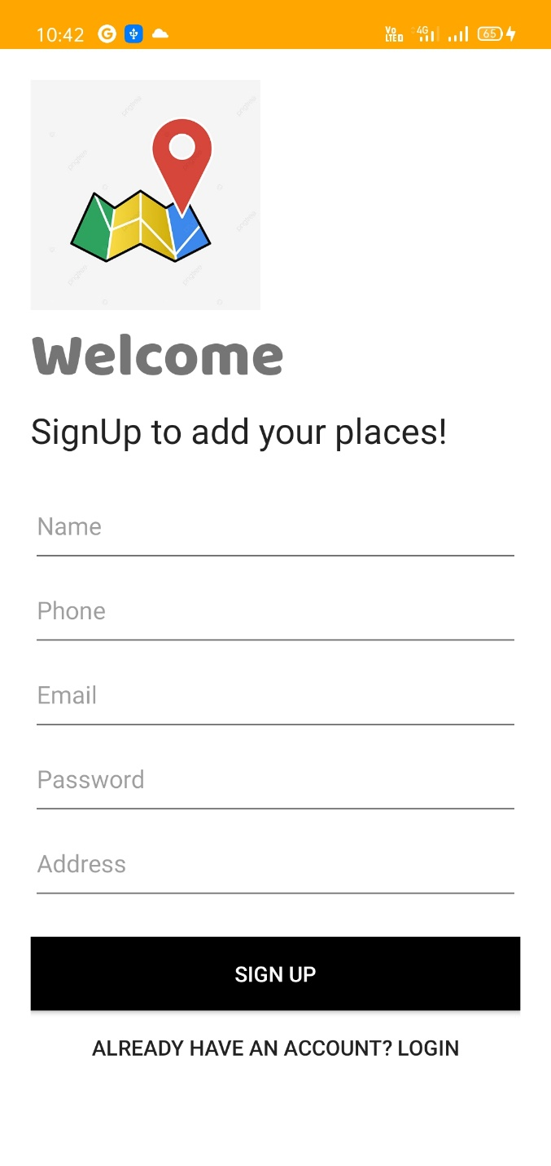

Owner Dashboard:

This is owner dashboard here he can select the type of place and upload his/her place info.

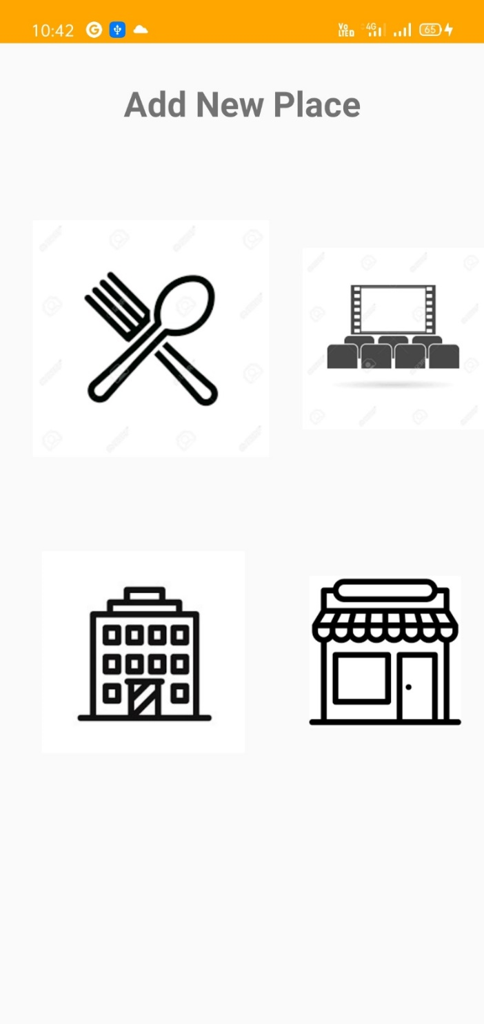

Owner Place Insertion Page:

Here he can add the details about the place ,after adding all the info he/she has successfully inserted their place in our application.

